Name : Alan Oakley |  | 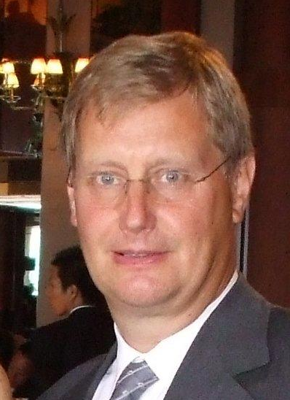
Year of Birth : 19/08/1949
Nationality : British
Country of Residence : UK
Profession : Arbitrator
Language(s) : Spoken English
Language(s): Written English
Telephone: + 447711279419
Email:apo@alanoakley.co.uk
Academic & Professional Qualification(s) :
FICS
FCIArb

Professional Membership(s):
London Maritime Arbitrators Association (LMAA)
Baltic Exchange London

Career & Professional Experience:
Forty years as a practicing shipbroker and arbitrator with commercial experience in ship owning, operating and chartering offices, including dry cargo, tankers and sale and purchase (including new building contracts).

Arbitration Experience:
Full time maritime arbitrator since 1997.

Publications:

